Experiment No. 6

Software Engineering Lab – Sequence Diagram (Behavioral View Analysis)

Aim: To draw the behavioral view diagram for ContextGuard — a repository-context-aware verification layer for reliable LLM-based code review: Sequence diagram

Theory:
What is Behavioral modeling?
All behavioural models really do is describe the control structure of a system. This can be things like:
- Sequence of operations
- Object states
- and Object interactions
Furthermore, this modelling layer can also be called Dynamic Modelling. The activity of creating a behavioural model is commonly known as behavioural modelling. As well as this, a system should also only have one behavioural model – much like functional modelling.
Two types of behavioral model are:
- Data processing models that show how data is processed as it moves through the system;
- State machine models that show the systems response to events.
- These models show different perspectives so both of them are required to describe the system’s behavior.

How to draw Sequence diagrams?
A sequence diagram is a kind of interaction diagram that shows how processes operate with one another and in what order. It is a construct of a Message Sequence Chart. A sequence diagram shows object interactions arranged in time sequence. It depicts the objects and classes involved in the scenario and the sequence of messages exchanged between the objects needed to carry out the functionality of the scenario. Sequence diagrams are typically associated with use case realizations in the Logical View of the system under development. Sequence diagrams are sometimes called event diagrams, event scenarios, and timing diagrams. A sequence diagram shows, as parallel vertical lines (lifelines), different processes or objects that live simultaneously, and, as horizontal

arrows, the messages exchanged between them, in the order in which they occur. This allows the specification of simple runtime scenarios in a graphical manner.

If the lifeline is that of an object, it demonstrates a role. Note that leaving the instance name blank can represent anonymous and unnamed instances.

Messages, written with horizontal arrows with the message name written above them, display interaction. Solid arrows with full heads are asynchronous calls and dashed arrows with stick heads are return messages. This definition is true as of UML 2, considerably different from UML 1.x. a caller sends a synchronous message, it must wait until the message is done, such as invoking a subroutine. If a caller sends an asynchronous message, it can continue processing and doesn’t have to wait for a response. You see asynchronous calls in multithreaded applications and in message-oriented middleware. Activation boxes, or method-call boxes, are opaque rectangles drawn on top of lifelines to represent that processes are being performed in response to the message (ExecutionSpecifications in UML).

Objects calling methods on themselves use messages and add new activation boxes on top of any others to indicate a further level of processing.When an object is destroyed (removed from memory), an X is drawn on top of the lifeline, and the dashed line ceases to be drawn below it (this is not the case in the first example though). It should be the result of a message, either from the object itself, or another.

Procedure:
- Identify various elements such as controller class, objects, boundaries, messages etc. of the sequence diagram.
- Draw the sequence diagram as per the guidelines.
- Identify various elements needed for a collaboration diagram
- Identify the behavior of the systems element with the external interfaces.
- Draw the collaboration diagram and State chart diagram as per the guidelines.

Output:
The sequence diagram below models the Fix-Guided Verification of a Flagged Pull Request workflow for ContextGuard, covering the Developer, GitHubConnector, LLMReviewService, HybridRetriever, TestSynthesizer, VerificationEngine, TestExecutionEnvironment, and Reviewer.
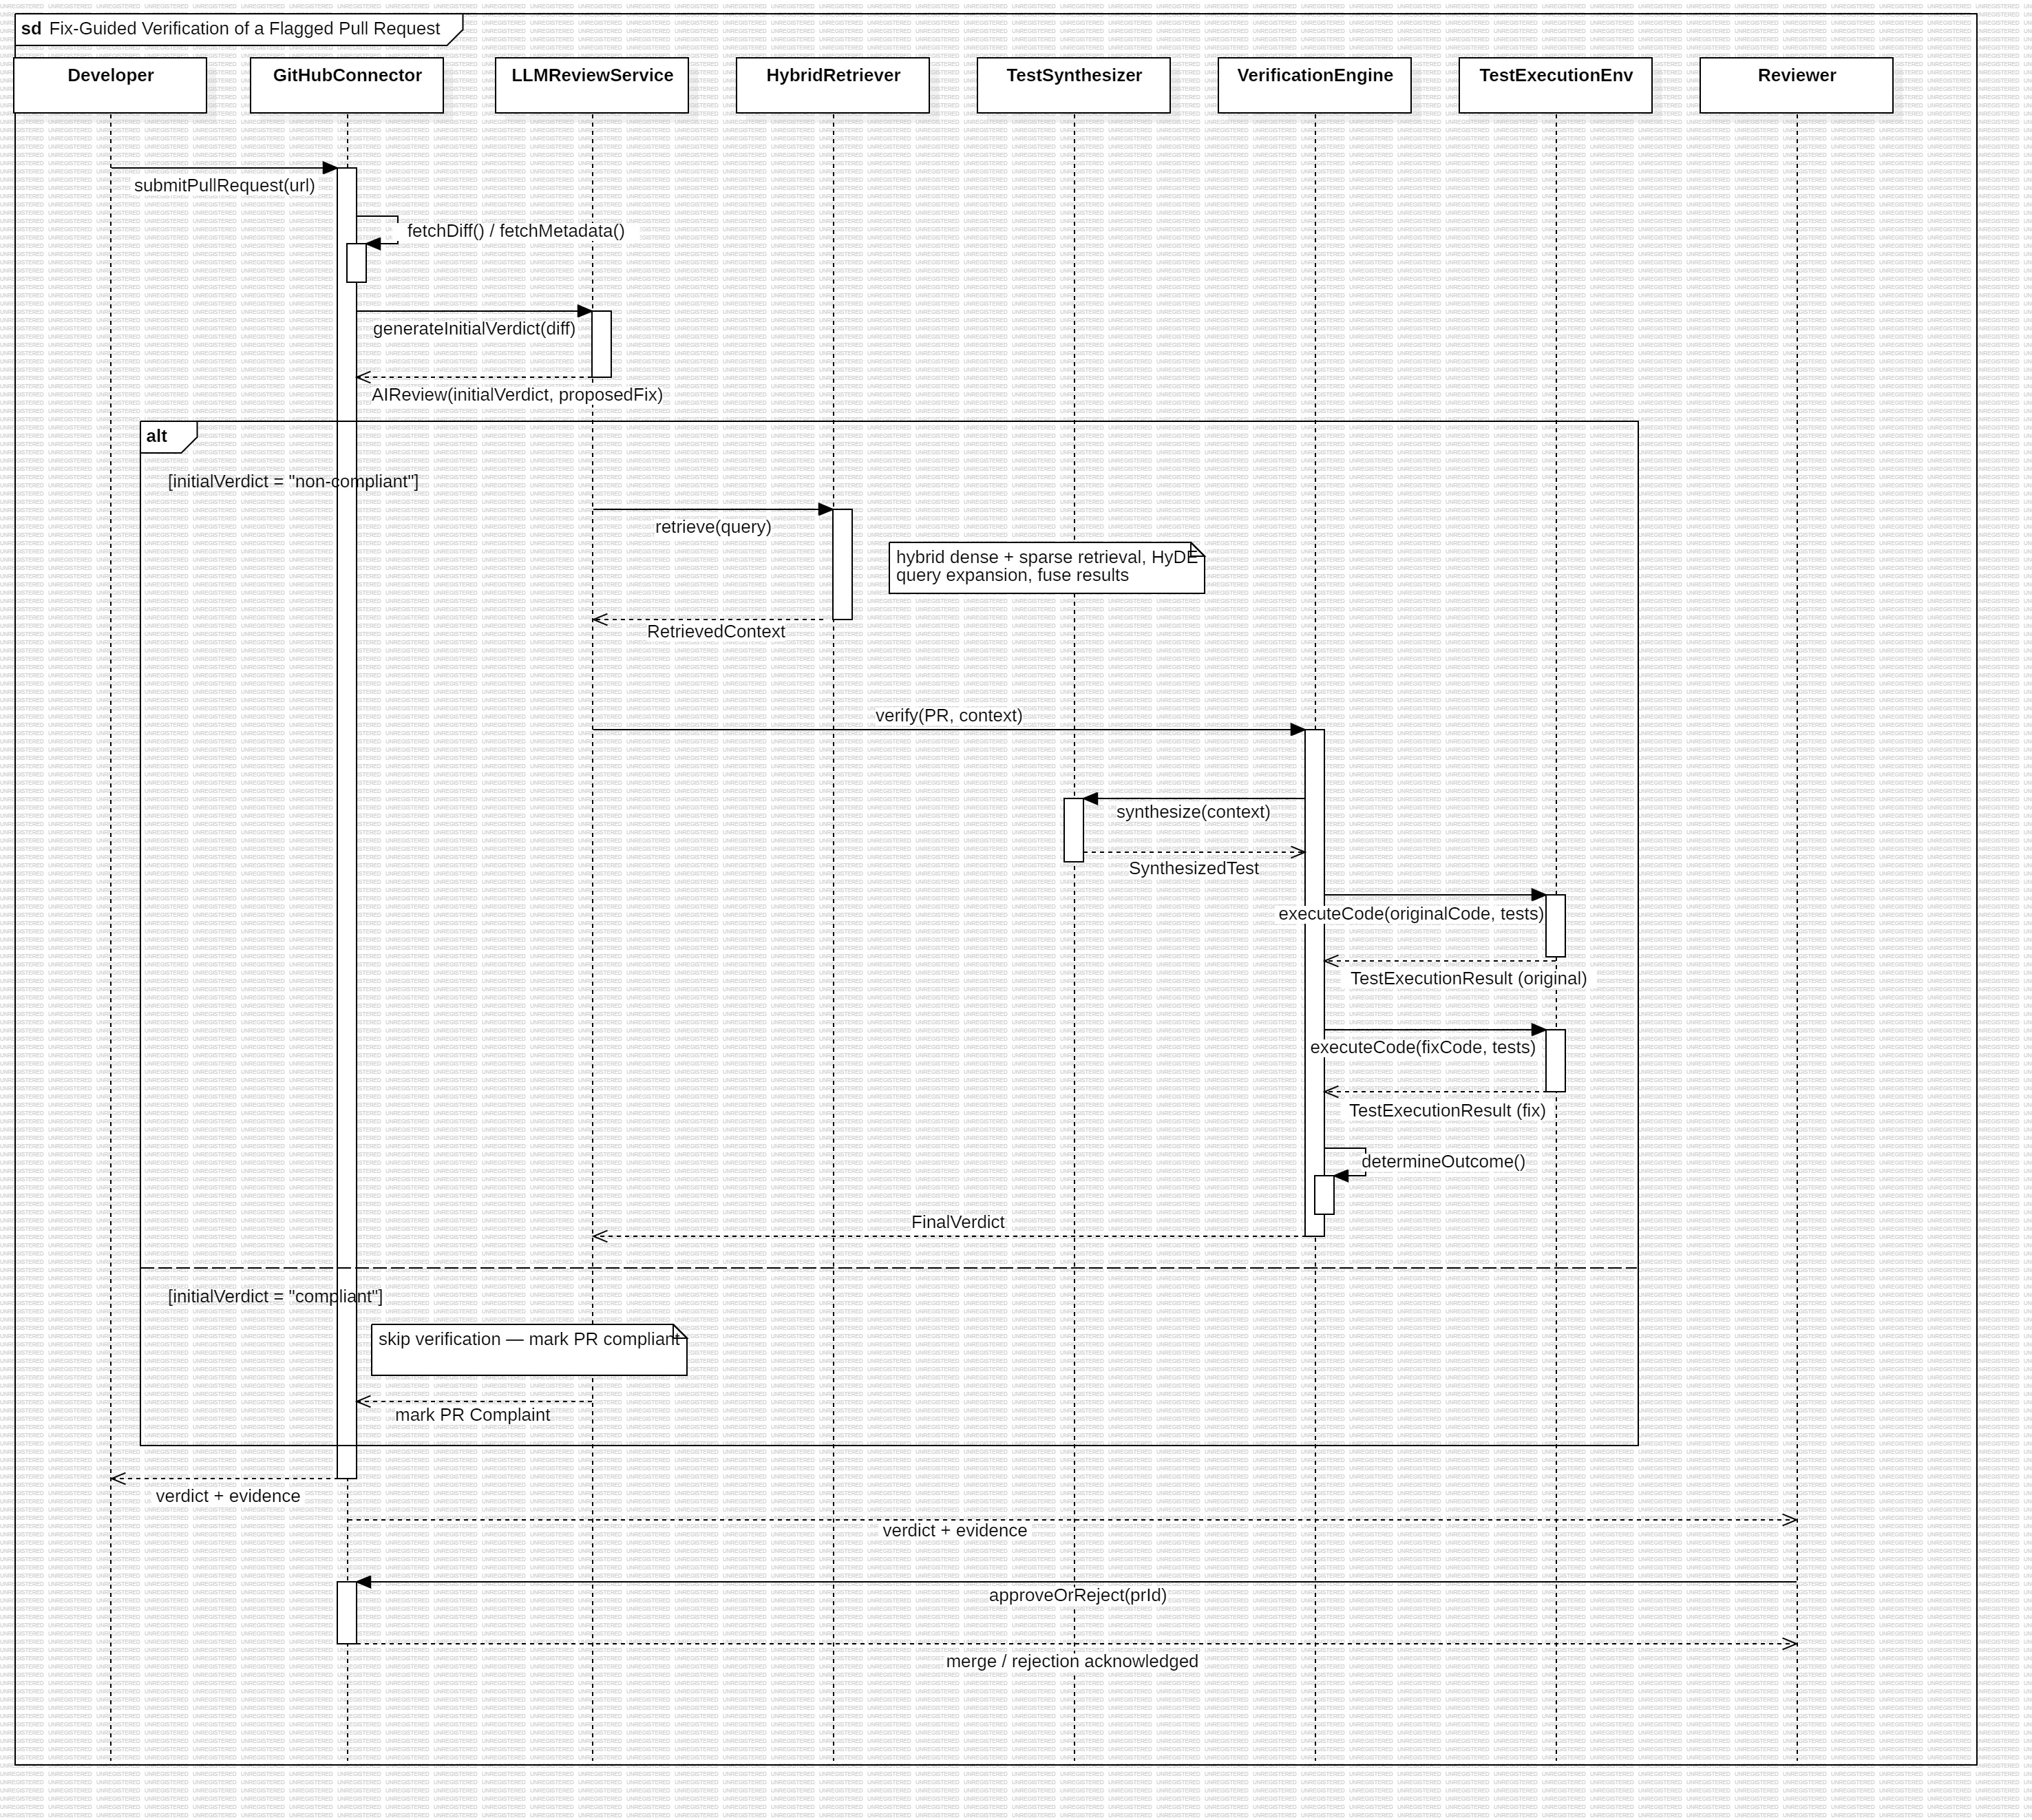
Fig. 1 — Sequence Diagram: Fix-Guided Verification of a Flagged Pull Request (ContextGuard)

Description
A sequence diagram is a behavioural UML diagram that represents the interaction between objects or components of a system in a particular sequence. It shows the order in which messages are exchanged between different participants during the execution of a specific system functionality. The vertical lines represent the lifelines of the participating objects, while horizontal arrows represent the messages exchanged between them.
The sequence diagram developed for this project represents the Fix-Guided Verification of a Flagged Pull Request workflow of ContextGuard. The main participants involved in this process are Developer, GitHubConnector, LLMReviewService, HybridRetriever, TestSynthesizer, VerificationEngine, TestExecutionEnvironment, and Reviewer.
The process begins when the developer submits a pull request. The GitHubConnector retrieves the pull request's code changes and metadata and sends the information to the LLMReviewService. The LLMReviewService generates an initial review verdict.
If the initial verdict identifies the pull request as non-compliant, the system starts the verification process. The HybridRetriever retrieves relevant code and context from the repository. This context is passed to the verification process, where the TestSynthesizer generates appropriate tests. The VerificationEngine then executes the tests against both the original and modified code using the TestExecutionEnvironment.
The VerificationEngine compares the obtained results and determines the final outcome. The final verdict and supporting evidence are then returned through the GitHubConnector to the developer and reviewer.
If the initial verdict is compliant, the verification process is skipped and the pull request is marked as compliant. The reviewer subsequently receives the verdict and evidence and can approve or reject the pull request.

Main Components / Lifelines
- Developer — submits the pull request and receives the verification result.
- GitHubConnector — communicates with GitHub and retrieves pull request information.
- LLMReviewService — uses the language model to generate the initial review verdict.
- HybridRetriever — retrieves relevant code and context using the repository retrieval mechanisms.
- TestSynthesizer — generates tests based on the retrieved context.
- VerificationEngine — coordinates test execution and determines the final outcome.
- TestExecutionEnvironment — executes the original and modified code with the generated tests.

Sequence of Operations
- The Developer submits a pull request through the system.
- The GitHubConnector retrieves the pull request's code changes and metadata.
- The retrieved information is sent to the LLMReviewService.
- The LLMReviewService generates an initial verdict.
- If the verdict is non-compliant, the system requests relevant repository context from the HybridRetriever.
- The HybridRetriever performs hybrid retrieval and returns the relevant context.
- The VerificationEngine initiates the verification process using the retrieved context.
- The TestSynthesizer generates tests based on the context.
- The VerificationEngine executes the generated tests against the original code.
- The VerificationEngine executes the same tests against the modified code.
- The TestExecutionEnvironment returns the test execution results.
- The VerificationEngine determines the final outcome.
- The final verdict and supporting evidence are returned to the GitHubConnector.
- The result is communicated to the Developer and Reviewer.
- If the initial verdict is compliant, the verification process is skipped and the pull request is marked as compliant.

Conclusion
The sequence diagram provides a behavioural representation of the Fix-Guided Verification of a Flagged Pull Request process for ContextGuard. It clearly shows the participating components, the messages exchanged between them, and the order in which the operations are performed. The diagram also represents the alternative behaviour for compliant and non-compliant pull requests. Thus, the sequence diagram helps in understanding the dynamic interaction and runtime behaviour of the proposed system.

